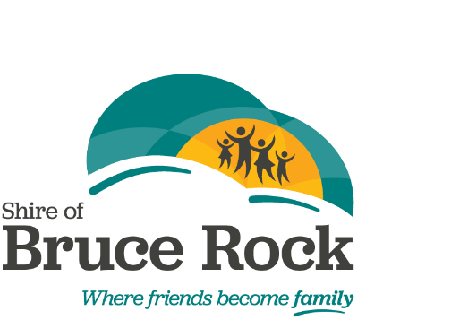
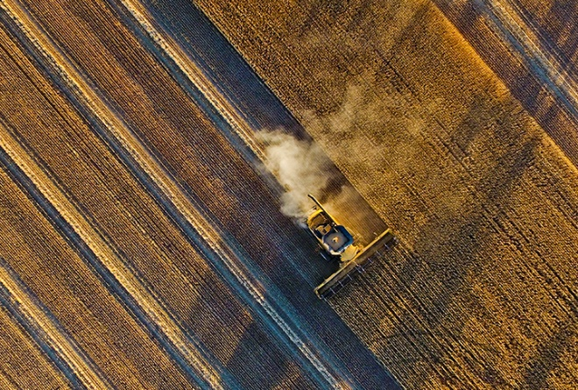
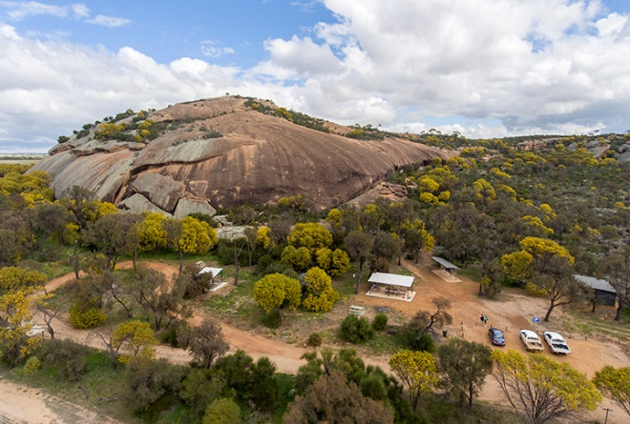
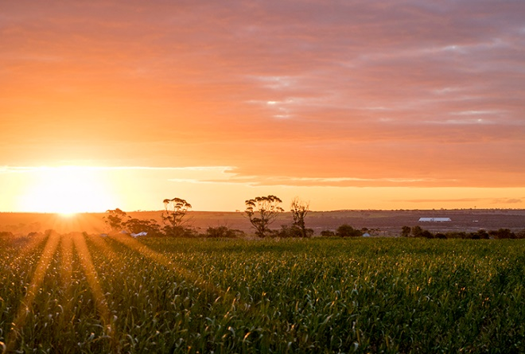

Applications to be received no later than 5.00pm
Date: Friday 5 April 2024
Late submissions will not be accepted

Please contact the Shire of Bruce Rock to discuss your application prior to submitting on
(08) 90611 377 or admin@brucerock.wa.gov.au.
Community Grant
Application Package
PURPOSE
To provide guidelines to incorporated and not for profit community organisations (including sporting groups) on the process to apply for financial assistance from the Shire of Bruce Rock to pursue chosen interests that meet the application criteria of the Community Grant Program (subject to budget constraints).

POLICY
The Shire of Bruce Rock will make an allocation of funds in its budget to provide financial assistance to incorporated and not for profit community organisations (including sporting groups) that can demonstrate an association with the Shire of Bruce Rock. Funding applications will be called for annually in March. This will be advertised through local media.

An allowance for these funds will be included in the draft budget, to a maximum of $20,000.

Examples of not for profit organisations include, but are not limited to:
- Sporting clubs
- Service groups
- P&C
- Art and cultural groups
- Other Shire of Bruce Rock local interest groups

Projects must seek to further the development of one of the following:
- Art and Culture
- Disability and Ageing
- Early Youth (0 to 4 years)
- Education and Training
- Environment
- Event Planning
- History and Heritage
- Minor Infrastructure, Equipment or Development
- Seniors
- Sport and Recreation
- Tourism
- Volunteer Upskilling
- Youth (5 to 18 years)

In awarding grants, priority will be given to projects that meet the objectives outlined in the Shire of Bruce Rock’s Strategic Community Plan 2022-2032, Goal 7 – Our community are engaged and have a healthy lifestyle.

The Strategic Community Plan can be found at: www.brucerock.wa.gov.au/documents/1624/strategic-community-plan-2022-2032

GRANT CATEGORIES
Minor Community Grants
Funding up to $1,000 or less, with no matching funds required from the applicant.

Major Community Grants
Funding between $1,001 - $5,000, with a 50:50 matching component, where successful applicants must contribute at least 50% of the total project cost from the applicant’s organisation or other confirmed funding sources. Evidence of other funding sources must be provided.

For projects over $5,000, please contact the Community Development Officer on 9061 1377 or admin@brucerock.wa.gov.au to discuss the project and alternative funding and grant opportunities.

INELIGIBLE EXPENSES
- Uniforms.
- Consumables (including food and beverages, stationary and other office supplies).
- Awards and prizes.
- Minor equipment (such as footballs, netballs, hockey sticks).
- Recurrent salaries and recurrent operational costs.
- Completed projects or equipment already purchased.
- Projects that are the responsibility of other government agencies.
- Deficit funding for organisations that are experiencing a shortfall in cash or revenue or anticipated revenue.

APPLICATION CRITERIA
- All applicants must be based within the Shire of Bruce Rock, with a majority of members of the applicant organisation preferably being residents of the Shire.

- All applications for financial assistance must be submitted on the Shire of Bruce Rock “Application for Financial Assistance” form.

- The applicant should submit documented estimates of expenditure as part of the application (i.e. quotes or written estimates from suppliers). All estimates should be GST exclusive.

- All applications must be received by the designated closure date and time. No late applications will be considered.

- Applications need to demonstrate the benefits to the community.

- For Major Community Grants, the contributions to the proposed project may come from one or more of the following sources:
- Applicant organisation’s cash.
- State or Federal Government funding agencies.
- Donations of material and/or cash.
- Voluntary labour (maximum 1/3 of total project cost).
  - Voluntary labour cost to be calculated at a maximum of $25 per hour.

- Only one (1) application per financial year for financial assistance from a Minor and Major Community Grant will be considered per organisation.

- Prior approval in writing must be sought for any substantial change to the assistance request.

- Payment of the grant funding can be made prior to incurring the expense. The Community organisation must provide a tax invoice to the Shire of Bruce Rock before 30 August 2024.

- Incomplete applications may not be considered.

ASSESSMENT

Applications for Minor and Major Community Grants will be assessed against the application criteria, and referred to Council for a final determination.

Preference will be given to projects with demonstrated community support.

All applicants will be notified in writing of the outcome of their application for a Shire of Bruce Rock Community Grant.

Decisions regarding funding applications are final and will not be reconsidered.

ACQUITTAL
Projects must be completed by 30 April 2025. Project and financial reports must be submitted to the Shire of Bruce Rock in “Section G Grant Acquittal” of the application, by 31 May 2025.

If projects are not finished and acquitted by the time the next Annual Round opens in March 2025, the community organisation may not be eligible to apply in that round.

Once an allocated budget has been utilised all subsequent requests for funding must be presented to Council for consideration.

FURTHER INFROMATION
Please contact the Shire of Bruce Rock to discuss your application prior to submitting on (08)9061 1377 or admin@brucerock.wa.gov.au.

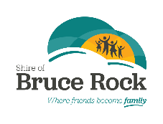
APPLICATION FOR FINANICAL ASSISTANCE
COMMUNITY GRANT

SECTION A – APPLICANT INFORMATION (to be completed by all applicants)
Organisation:
Contact Person:
Position Held:
Postal Address:
Telephone:
Email:

Funding Request
Total In Kind Requested: $________________________
Total Project Budget (ex gst): $_____________________
Funding Requested (ex gst): $______________________

SECTION B – INFORMATION ABOUT YOUR ORGANISATION: (all questions must be answered)
- What are the main services and/or activities of your organisation?
______________________________________________________________________________________________________________________________________________________________________________________________________________________________________________________

- What are/were your membership numbers? Please break down membership into Total Members, Adult Members, High School Aged Members and Junior Members.

 | Juniors | High-School | Adult | Total Members
2020
2021
2022
2023

- Were your 2020 and/or 2021 membership numbers affected by COVID19? If so, how?
______________________________________________________________________________________________________________________________________________________________________________________________________________________________________________________

- Is your organisation incorporated? If yes, please attach your certificate of incorporation.
Yes No Incorporation No: __________________

- Does your organisation have an ABN?
Yes No ABN No: __________________

- Is your organisation registered for GST?
Yes No

SECTION C – PROJECT DETAIL
MINOR GRANTS ONLY (up to $1,000)
What area of interest does your application relate to: (please tick all relevant areas)
  - Art and Culture
  - Disability and Ageing
  - Early Youth (0 to 4 years)
  - Education and Training
  - Environment
  - Event Planning
  - History and Heritage
  - Minor Infrastructure, Equipment or Development
  - Seniors
  - Sport and Recreation
  - Tourism
  - Volunteer Upskilling
  - Youth (5 to 18 years)
  - Other: __________________________________

MAJOR GRANTS ONLY (between $1,001 and $5,000)
What area of interest does your application relate to: (please tick all relevant areas)
  - Art and Culture
  - Disability and Ageing
  - Early Youth (0 to 4 years)
  - Education and Training
  - Environment
  - Event Planning
  - History and Heritage
  - Minor Infrastructure, Equipment or Development
  - Seniors
  - Sport and Recreation
  - Tourism
  - Volunteer Upskilling
  - Youth (5 to 18 years)
  - Other: __________________________________
Project Name: _____________________________________________________________________
Project Location: ______________________________________________________________________________________________________________________________________________________________________

Expected project start and finish dates
Start Date: ___________________
Finish Date: ___________________

What is the funding being used for?
- Purchasing goods and services, such as sporting equipment or materials or engaging professionals for the purpose of instruction.
- Infrastructure, such as significant construction or improvements of a facility.
(Please include building and planning approvals, if required. If the project is in a Council owned building, permission must be sought from Council prior to application.)
- Funding for specific event or programs.
- In kind assistance (venue/bus hire etc). Separate letter of request addressed to the Chief Executive Officer will be required.
Have you applied for funding through any other sources for this project?
- Yes
- No
If Yes: Which organisation? _________________________________________
What Year? _________________________________________________
Was it Successful? ____________________________________________
Grant Approved $ ___________________________________________
If you were successful in receiving funding from other sources, please attach documents to confirm.

If No, are you planning on applying for funding through other organisations?
__________________________________________________________________________________________________________________________________________________________________________
Does your project require any approvals?
- Yes (please attached relevant documentation)
- No

Project Description:
Please summarise your project, including what your project is, how it will be managed, who it will cater for, what benefits or services it will offer or improve.
Describe your project:
________________________________________________________________________________________________________________________________________________________________________________________________________________________________________________________________________________________________________________________________________________________________________________________________________________________________________________________________________________________________________________________________________________________________________________________________________________________________________________________________________________________________________
How will the project be managed?
________________________________________________________________________________________________________________________________________________________________________________________________________________________________________________________________________________________________________________________________________________________________________________________________________________________________________________________________________________________________________________________________________________________________________________________________________________________________________________________________________________________________________
Who will your project cater for?
________________________________________________________________________________________________________________________________________________________________________________________________________________________________________________________________________________________________________________________________________________________________________________________________________________________________________________________________________________________________________________________________________________________________________________________________________________________________________________________________________________________________________
What benefits or services will it offer or improve?
________________________________________________________________________________________________________________________________________________________________________________________________________________________________________________________________________________________________________________________________________________________________________________________________________________________________________________________________________________________________________________________________________________________________________________________________________________________________________________________________________________________________________
Please include any other details or supporting information/documentation
(i.e. letters of support, photographs, maps)
List of Attachments
- ___________________________________________
- ___________________________________________
- ___________________________________________
- ___________________________________________
SECTION D – PROJECT BUDGET
Is your organisation registered for GST?
- Yes
- No
INCOME | NET INCOME
Council Contribution (grant funds requested in this application) | $ | ex gst
Council Contribution (other – e.g. site works) | $ | ex gst
Total Council Contribution Requested | $ | ex gst
Other Grant Funding (please specify) | $ | ex gst
Donations (external contributions) | $ | ex gst
Organisation Cash Contribution | $ | ex gst
Organisation In Kind Contributions (max 1/3 of total cost) | $
Total Organisation Contribution | $ | ex gst
TOTAL INCOME excluding gst | $ | ex gst

EXPENDITURE | In kind | Cash | Total
 |  |  |  | ex gst
 |  |  |  | ex gst
 |  |  |  | ex gst
 |  |  |  | ex gst
 |  |  |  | ex gst
 |  |  |  | ex gst
 |  |  |  | ex gst
 |  |  |  | ex gst
 |  |  |  | ex gst
 |  |  |  | ex gst
 |  |  |  | ex gst
 |  |  |  | ex gst
 |  |  |  | ex gst
 |  |  |  | ex gst
 |  |  |  | ex gst
 |  |  |  | ex gst
 |  |  |  | ex gst
 |  |  |  | ex gst
TOTAL EXPENDITURE excluding gst | $ | $ | $ | ex gst

SECTION E – CONDITIONS
If the grant funding is awarded to the organisation then the organisation shall agree to the following conditions:
- The grant will be used for the purpose which it was given.
- If successful in your application, your organisation is required to provide the Shire of Bruce Rock with a tax invoice before 30 August 2024 for the amount of allocated funds.
- The acquittal must be returned to the Shire of Bruce Rock within one month of completion of your project or by 31 May 2025. Copies of project receipts must be attached.
- The Shire of Bruce Rock will issue an invoice to the organisation for any unspent funds.
- If there is any delay in the completion of the project or expenditure of grant funds, a written request will be made to the Shire of Bruce Rock seeking approval for extension of time.
- A grant will not be approved for a project that has commenced or has been completed.
- Any special conditions that are attached will be met.
- All relevant records will be kept for a period of seven years, and will be made available for audit at any time.
- The Shire of Bruce Rock will be acknowledged in any publications or media coverage for its support.
- Your project should be discussed with the Shire of Bruce Rock’s Community Development Officer prior to applying.
- Keep a copy of your application for your records.
  - The Shire will contact you if more information is requested.
  - All applicants are advised in writing of the outcome.
  - Applications are processed in the order in which they are received. If any required documentation is not included in the first instance, the processing of your application will be delayed.
  - Assessment will take a minimum of one month.

Summary of grant timeline
Community Grant Process | Due Date
Applications open | 5 March 2024
Applications close | 5 April 2024
Notification of application outcome | 29 April 2024
Tax invoice to Shire of Bruce Rock for funding allocation | 30 August 2024
Last date for project completion | 30 April 2025
Last date for project acquittal | 31 May 2025

SECTION F – DECLARATION
I, the undersigned, certify that I have been authorised to submit this application, accept the undertakings and conditions of the application and that the information contained herein and attached is to the best of my knowledge true and correct.
Name/Organisation
Contact Person
Position
Signature
Date

Attachments Checklist
Please check that all relevant documents are included with the completed application. This may include, but not limited to:
- Certificate of Incorporation
- Quotes or estimates for expenditure
- Any approvals required for this project
- Evidence of other funding
e.g. letter advising of successful grant application or receipt of funding application pending, letter advising of donation to your group.

Please return your application to:

Community Grant Program
Shire of Bruce Rock
54 Johnson Street
Bruce Rock WA 6418
E: admin@brucerock.wa.gov.au

APPLICATIONS CLOSE 5 APRIL 2024

THIS PAGE IS INTENTIONALLY LEFT BLANK

SECTION G – ACQUITTAL FORM AND FINANCIAL STATEMENT
Organisation Name:
Contact Person:
Postal Address:
Telephone:
Email:
Name/Description of Project
Grant Amount:

What were the aims of the project and did you achieve them?
_______________________________________________________________________________________________________________________________________________________________________________________________________________________________________________________________

Describe your completed project:
_________________________________________________________________________________________________________________________________________________________________________________________________________________________________________________________________________________________________________________________________________________________________________________________________________________________________________

Who was involved in your project and in what capacity?
_________________________________________________________________________________________________________________________________________________________________________________________________________________________________________________________________________________________________________________________________________________________________________________________________________________________________________

What were the benefits for the participants and/or what did the project improve?
_________________________________________________________________________________________________________________________________________________________________________________________________________________________________________________________________________________________________________________________________________________________________________________________________________________________________________

Please provide any other comments:
_________________________________________________________________________________________________________________________________________________________________________________________________________________________________________________________________________________________________________________________________________________________________________________________________________________________________________

FINANCIAL STATEMENT

PROJECT EXPENDITURE | AMOUNT
TOTAL EXPENDITURE | $
PROJECT INCOME | AMOUNT
TOTAL INCOME | $
NOTE – total expenditure should equal total income

Have you spent all the grant funding?
- Yes
- No
If you have not fully expended the grant money, what is the balance remaining? $ __________________
The Shire of Bruce Rock will invoice your group for any unexpended funds.
Attachments Checklist
- Copies of project invoices/ receipts
- Any other relevant material – promotional flyers, advertising, photos or newsletters
- Evidence or recognition of Shire of Bruce Rock assistance

Signature: | Date:
Name: | Position:

Please return your completed acquittal form to:
Shire of Bruce Rock
54 Johnson Street
Bruce Rock WA 6418
admin@brucerock.wa.gov.au

