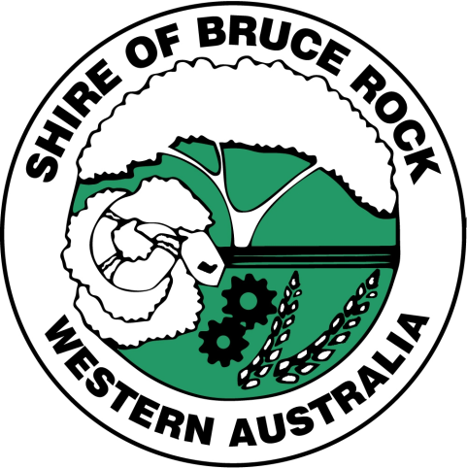

Community Strategic Plan Review
The Shire of Bruce Rock is currently reviewing its Community Strategic Plan and would like your input. This will ensure that the plan reflects the needs of the community. The Shire would like your thoughts on the current community vision for the Shire. It’s also looking for your feedback on a range of strategies within the plan.
Input can be provided via an online survey, which can be accessed via: https://www.surveymonkey.com/r/BruceRock
A hard copy version of the survey can also be completed at the Shire office or CRC. It is a very short survey and should only take around 5 minutes to complete.
- Additionally, Caroline Robinson who is completing the community consultation for the Shire of Bruce Rock will be available via phone to discuss your thoughts anytime and will be meeting with a number of local community, sporting, business and service groups over June and July. She can be contacted on 9880 8035 / 0403 225 900 or eo@wheatbeltbusinessnetwork.com.au
We look forward to hearing from you. We value our community’s input, as it plays an important part in shaping Council’s strategic direction over the next 10 years. We want to know what you see as important and what you value in our community.

